**Natural Science findings from the Loweswater RELU project**

Under Objective 2 in the RELU project this work aimed at producing high quality research on which to base informed decision making

***1a) Terrestrial Ecology and Farm Economy***

To understand the actual and potential *ecological and economic* value of land in Loweswater. and the relationships between them.

***1b) Linking Terrestrial and Aquatic systems***

To assess, monitor and model the relationship between land/waste management in the catchment and *water quality and biotic diversity* in the lake.

* 1. **The catchment knowledge-base**

*The farm economy and terrestrial ecology*

Approach

Established survey methods (as used in the Countryside Survey, 2007) were employed to measure the ecological and landscape attributes of the land in the catchment. An agricultural/economic assessment of the catchment was made in collaboration with the farmers by a trusted local farm business advisor (John Rockliffe), who collected data on stocking rates, farm income, fertilizer application, and other parameters needed to create a farm P (phosphorous) budget.

Findings and outcomes:

* The total land area of the Loweswater catchment is 7.6km2 (7600 ha). During the period of the project there were 6 farms with their buildings and at least some associated land in the Loweswater catchment. At the time of the survey, farmland in the catchment was managed by up to 9 farmers with some parcels on short–term tenancies. There were 8 farmers with in-bye land in catchment.
* The area of fell/intake land within the catchment used for each of the 8 farms ranged from 100 ha down to 0 ha, with an average per farm of 40 ha. For In-bye land, the range was from 106 ha down to 12 ha, with the average, again, of 40 ha. All of the farms had land outside the catchment ranging from one farm with very little land in the catchment to two others with virtually all their land inside the catchment.
* Historically, all farmland has been included in the Environmentally Sensitive Area’s (ESA) scheme with farmers having entered the scheme between 1993 and 1996. Land on 6 holdings will continue to be under ESA prescriptions until 2012-2014 (two ten year agreements, dependant on starting date). The three farmers no longer in ESA have, after a gap of between 3-5 years, reapplied for agreements under the Entry Level Scheme, Upland Entry Level Scheme and Higher Level Scheme during the course of the project.
* The catchment contained a mix of 13 Broad Habitats. The most significant area consisted of mixed upland habitats (Bracken, Acid Grassland, Dwarf Shrub Heath, Bog, Fen, Marsh Swamp and Rock (in total 48% of the area), with agricultural grasslands together with a very small area of arable land forming the next most extensive in area (37%). Woodland (13%) and buildings and garden (2%) formed the only other substantial areas of habitat.



* The upland areas fall under the Moorland designation made by the Rural Payments Agency. This affects payments under the Single Payment Scheme and also agri-environment schemes. In-bye land is classified as Severely Disadvantaged.
* At the time of the survey, the catchment included a substantial total length (152 km) of mixed linear features. The majority of these were fences which are frequently associated with other features (including sometimes a secondary fence). There were over 27 km of stream within the catchment, all of which led down to the lake. Traditional stone walls formed the most common (non-fence) field boundary feature with over 18 km across the lowland part of the catchment, whilst earth and stone banks (13.5 km) commonly formed field and stream boundaries. There were over 7 km of well maintained hedges in the catchment and twice as many lines of trees. Some of the lines of trees occurred at the same location as the hedges. Others probably resulted from abandoned hedge management.
* 70% of walls were in good condition, although the other 30% showed signs of deterioration. Hedges out of condition were defined as lines of trees (as above). There were approximately 500 individual trees standing alone (including some in hedges) or in small clumps around the catchment, many of which were well established.
* The majority of the agricultural grassland within catchment was used for grazing with only some 69 ha used for silage or hay production. This relates to the small quantity of land suitable for mowing within the catchment as well as the farming system adopted by some of the farmers. Upland areas (fells) were grazed predominantly only by sheep, although cattle graze in some areas which were historically farmed more intensively.
* All the farms, except one, had a suckler cow herd on the holding of up to 70 cows. The total number of suckler cows being carried on the catchment land was 194. Generally calves from the suckler herd were sold as ‘stores’ rather than being sold ‘finished’.
* All the farms carried flocks of breeding sheep kept for the production of breeding stock and finished lambs. The total flock size within catchment was 1417 ewes, an average of 177 per holding. The stocking rate ranged from 1.74 Livestock Units (LUs)/ha down to 0.34 LUs/ha, being typically around 1.0LU/ha.
* In order to improve business sustainability a number of the farmers had developed diversification enterprises in the past such as agricultural contracting, B & B and camping barns, for example. These significantly added to the farm income and helped to deliver sustainability.
* For those businesses that provided the information, income from the traditional agricultural sources amounted to as little as 32% of total income at one extreme and as much as 58% at the other end of the scale, with 50% being a ‘typical’ figure. This was very much in line with similar farms in the North West. For the 81 ‘LFA Grazing Livestock’ farms participating in the Farm Business Survey for 2007, 55% of Total Farm Output was derived from ‘farming sources’. More specifically, for the Survey Farms the farming income was £36,000 compared to the total output of £66,000 while Farm Business Income was just £7,000.
* The age structure of farmers in the catchment was not dissimilar to that of farmers elsewhere, with the majority of farmers over 50 years of age. Of the 8 farmers, 3 had descendents who were likely to take on the farm.
* Some 62 groups of fields were analysed on the in-bye land in the catchment (grouping based on past and present use), of these only 6 had a pH of 6 or above, i.e. only 10% of samples analysed. The rest were typically around pH 5.5, which may not sound too low but as the pH scale is logarithmic it represents a three-fold significant increase in acidity.
* Of the 62 field samples, 23 (37%) were below P index 2 and 18 (29%) were below K index 2. A low P or K index is not in itself a problem, provided adequate levels of nutrient are applied for the crop being grown to allow for the desired level of production and to reduce the risk of further reduction in soil nutrient reserves. If less than the required level of nutrient is applied, crop growth will be affected and nutrient status in the soil further compromised.
* 
* *P indices of fields in the Loweswater catchment 2009 (all fields in yellow or green were below P index of 2, oranges and red were above 2 with those in the brightest red above 3).*
* Six out of the 8 farmers were applying surplus potassium but only 3 out of 8 were applying surplus phosphorus. However, overall there was a disparity between areas with a shortfall in P and others with a surplus. P indices were, as expected, highest on arable land and on silage land.
* An analysis was carried out to compare the Loweswater catchment with areas of a similar landscape type across England. This showed that agricultural grassland in the Loweswater catchment contained approximately the same number of species as agricultural grassland elsewhere. It also showed that, on average, a square km in the Loweswater catchment contained a greater diversity of habitat types than a comparable 1km square elsewhere (12 as opposed to 7.5). One kilometre squares in the Loweswater catchment were also more likely to contain woods and water than 1km squares elsewhere. Other research has shown the existence of both woods and water to be very important for people’s enjoyment of the countryside. Similarly, the number of non-woodland trees per 1 km square in the catchment was higher than in comparable landscapes. The Loweswater catchment also contained a greater number of hedges and lines of trees than other 1 km squares in similar landscapes.
* Farming, farm buildings, farm management are all integral to the landscape composition and character of the Loweswater catchment. Farming, in many ways, has a positive impact on the Loweswater catchment providing it with cultural and ecological value, in terms of providing a varied and interesting landscape.







*Linking terrestrial and aquatic ecological monitoring*

Approach

A monthly lake monitoring programme, using standard techniques, was carried out over 3 years. Additionally, a meteorological station with additional lake monitoring equipment was installed on a buoy on Loweswater. Data, down-loaded by telemetry, included: temperature profiles, oxygen concentration, temperature, pH, conductivity at surface and depth, and surface chlorophyll *a*. Data were uploaded to the project web-site. Meteorological data were used to drive a lake model linking land cover and management to water quality and the in-lake data were used in model validation. Terrestrial ecology and farm management data were incorporated into a Geographical information system (GIS) to link management practices with the environmental quality of the land. Data on terrestrial and aquatic ecology were used in catchment modelling. The modelling process was opened out to knowledge inputs beyond those originally envisaged. The modelling methodology used a series of linked models to assess Phosphorus (P) runoff from the catchment to the lake and its impact on water quality. Outputs from a farm nutrient budget model, Planning Land Applications of Nutrients for Efficiency and the environment (PLANET), fed into a hydrological model (GWLF) and nutrient outputs from the hydrological model fed into the algal production model (PROTECH). In addition to a ‘current conditions’ scenario as input to the model, four further scenarios were explored to reflect alternative land management options. Non-farming scenarios included a wooded (deciduous) catchment (‘woodland’ scenario), and a no-input grassland scenario without livestock (‘natural grassland’). Farming scenarios included: ‘no cattle, double sheep numbers’ and ‘double cattle, half sheep numbers’ representing potential, though extreme, changes in the livestock composition of the catchment. Nutrient loads from septic tanks (from an LCP study by Webb, 2010) were input to the GWLF model in two ways: 1) as a diffuse source of nutrients where P discharge from septic tanks was incorporated into the farm nutrient budget in the same way as other sources of nutrients; and 2) as a point source of nutrients where effluent was assumed to discharge directly to the watercourse, i.e. a worst case scenario.

Findings and outcomes:

* Evidence from lake cores and direct measurements showed that the water quality in Loweswater had deteriorated gradually over the last century and a half, and more rapidly in the last fifty years. This was caused by higher concentrations of phosphorus in Loweswater and led to increased algal populations (assessed as the concentration of chlorophyll *a*), a tendency to produce cyanobacteria (blue-green algae), and severe oxygen depletion at depth during summer stratification.
* The relatively slow throughput of water in the lake makes Loweswater more *s*ensitive to the effects of phosphorus-enrichment by reducing the loss of phytoplankton by flushing, and also by allowing relatively slow-growing cyanobacteria to persist for much of the year.
* In recent years, there has been some indication of a slight improvement in water quality compared to the early 2000s. In 2008-2010, annual concentrations of phosphorus and phytoplankton chlorophyll (a measure of abundance) were lower and the oxygen concentration at a depth of 6–8 m was slightly higher.



Trends in total phosphorus concentrations in Loweswater 1980-2010 (Winter, Spring, Summer and Autumn)



Trends in total phytoplankton Chlorophyll a concentrations in Loweswater 1980-2010 (Winter, Spring, Summer and Autumn)

* Although most fields were not over-fertilized with phosphorus, the optimal amount of phosphorus in soils for *agricul*tural productivity still leads to a loss of phosphorus to watercourses and the lake.
* Models linking farm management, land use, hydrology and usin*g meteorol*ogical data from the monitoring buoy an*d land-*use data were run for the current conditions and possible future scenarios of land-use. These data fed into the lake model PROTECH which forecast the amount and type of *phytoplan*kton algae produced. There was a clear relationship between annual load of phosphorus to the lake and amount of phytoplankton chlorophyll and cyanobacteria produced. The relationship tells us the likely levels of phytoplankton and blue-green algae that result from different P loads and could be a useful tool to evaluate the effect on the lake of different future scenarios and in particular the reduction of phosphorus needed to bring the lake to ‘good ecological status’, as required for the EU Water Framework Directive.





*Total chlorophyll and Cyanobacteria chlorophyll measured (X’s) in Loweswater (0=Jan 1) in 2009. Lines indicate modelled chlorophyll as produced by the PROTECH model.*

**

*Modelled relationship between annual mean cyanobacterial chlorophyll a and phosphorus load for a range of scenarios. The point outlined in red indicates the current scenario which was validated by current lake data, (i.e. the model predicted the measured values for chlorophyll based on actual phosphorus load correctly for conditions in 2009).*

*Fish ecology*

Approach

Fish populations were investigated using three approaches: 1) a historical perspective through a student dissertation; 2) analysis of unpublished data on recent fisheries performance in the lake and on fish abundance from electrofishing in its inflowing and outflowing streams provided by the NT and EA, respectively; and 3) scientific assessments of the lake’s fish community conducted in the summers of 2007, 2008 and 2009 combining night-time survey gill nets and hydroacoustic surveys during the day and night to produce information on fish species, abundance, individual condition and spatio-temporal distributions.

Findings and outcomes:

* Andrew Shaw’s work on fish at Loweswater indicated that 100 years ago recreational angling for brown trout at Loweswater was widely acknowledged as among the best game fishing in the North of England. It also showed that this had only been achieved by the extensive stocking of brown trout. Significant declines in the quality of trout, by the middle of the last century, led to native perch and pike being subjected to major removal programmes in the 1970s. Subsequently, further stocking with brown trout was undertaken resulting in a temporary improvement in fishing by the mid 1980s. Analysis of fishery information kept by the National Trust and the Environment Agency in recent years indicates that that brown trout and salmonid populations have once again declined in the catchment.
* Results from the gill-netting surveys showed that perch overwhelmingly dominated the fish community of Loweswater, with much lower numbers of brown trout, minnow and pike. Offshore, few fish were recorded in the deeper parts of the lake, probably as a result of the very low oxygen concentration. However, hydroacoustic surveys detected abundant targets at depth during the day that rose to the surface at night. Direct sampling showed these targets to be phantom midge larvae, *Chaoborus,* for whichlow oxygen at depth provides a refuge from fish predation. The existence of the larvae in Loweswater may affect the food chain and the amount of algae the lake can support.
* Findings from the fish survey work are detailed below:



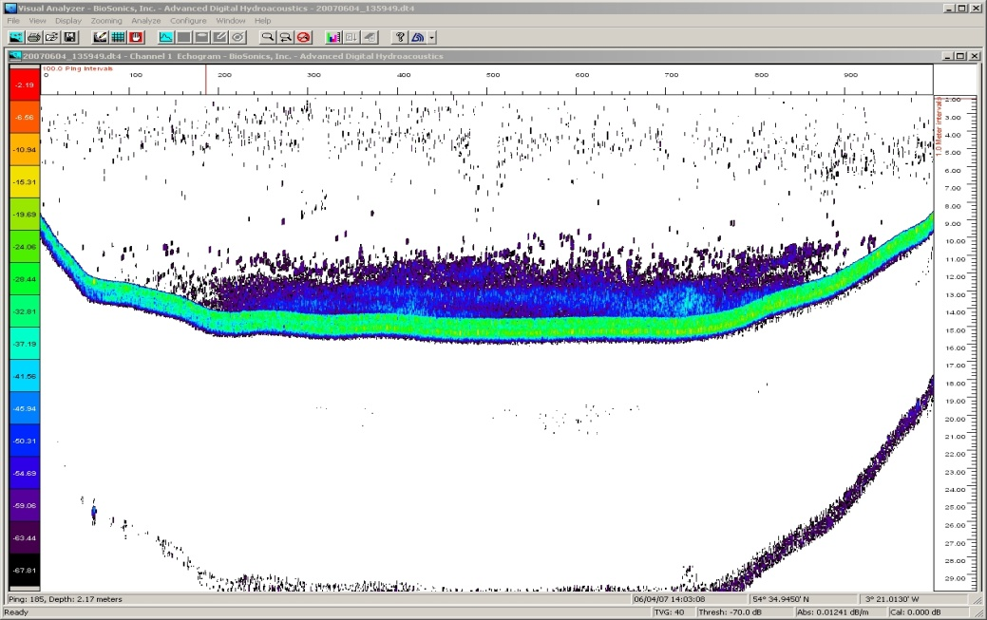

*Hydroacoustics in Loweswater – sampled on 4 June and 24 June 2007 DAYTIME (shows ver y few fish)*

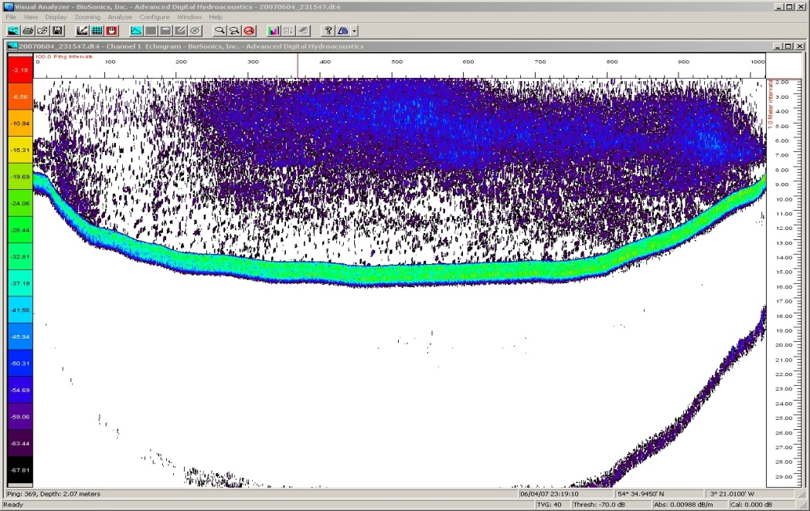

*Hydroacoustics in Loweswater – sampled on 4 June and 24 June 2007 NIGHT TIME (shows ver y few fish)*

**

*Abundance of different size classes in the hydroacoustic measurements*

**

*Fish abundance and phosphorus concentrations.*

*Winfield, I. J., Fletcher, J. M., James, J. B., Bean, C. W. & Duigan, C. (in press). Setting reference values for lake fish abundance: observations from unexploited or lightly exploited vendace (Coregonus albula), whitefish (C. lavaretus) and Arctic charr (Salvelinus alpinus) populations in the U.K. In: Cowx, I. G. (editor) Assessing the Ecological Status of Rivers, Lakes and Transitional Waters. Fishing News Books, Blackwell Scientific Publications, Oxford. Indicates Loweswater*